Report on Social Protection Services in Jamaica

Maziki Thame and Tricia-Anne Morris

Review of the “Jamaica Social Protection Strategy”

Overview
The Jamaican government developed a Social Protection Strategy (SPS) as part of its social safety net reform programme that was initiated in 2000. It seeks to target the most vulnerable, to create efficiencies within the social safety net system and to focus on the risks to income security and chronic poverty (PIOJ 2014, 1). Its preventative approach is said to be based in a conceptual vision of basic needs as human rights, social risk management and transformative social protection (which alters the social and cultural biases that make individuals susceptible to economic risk and vulnerability) (Ibid, 5). The targeting of the most vulnerable adopts a limited vision of poverty in Jamaica as it addresses those at the very bottom (falling below the poverty line) and not the wider reality of poverty in Jamaica (for instance, the working poor, and those within the lower middle class). Indeed, the SPS suggests that the state move away from universal provisions such as those in the education system, towards targeted access so as to make social protection more affordable. (See ibid, 92-93). At the same time, the SPS states that:
social protection is required not only for the poor. Rather it is necessary to ensure that provisions are in place to protect all residents from threats that would prevent them from enjoying living standards that meet established criteria. Universal provisioning is also an important feature of the conceptualization of SP that recognizes its contribution to national development and economic well-being through smoothing of consumption and stabilization of aggregate demand (Ibid, 39).
Universal access is to be made for primary health care, education up to the secondary level, potable water, waste disposal, food and nutrition security, shelter and infrastructure necessary for access to goods and services (Ibid, 42). This list collapses provisions made within the normal use of taxes into the social protection system.

The SPS is bound by a model of financial constraint or what is deemed as the limited resources of the state. Consequently, there is significant emphasis on divesting the responsibilities of the state, finding market-based solutions, such as insurance and micro-financing for the poor, and building partnerships with other actors in the sector. Key to the partnership is encouraging the citizen to be responsible. That view is embedded in the state’s broader developmental approach captured in Vision 2030 Jamaica, the National Development Plan of Jamaica, and the slogan “self-help within a supportive framework”. Guiding principles are named in the order: personal responsibility, inclusiveness, equity and smart programming (Ibid, 7). Personal responsibility and private sector partnerships are thought to “relieve the government of some of the financial burden of the social protection system (Ibid, 13).

A limitation of the SPS is that it is not geared at transforming the macro-economic context that produces poverty and inequality in Jamaica although it claims to address the “root causes of social insecurity” (Ibid, 1). It argues that social protection (SP) “does not embrace macro-economic policies, but treats these as providing the context within which SP operates and may be supportive or conflicting” (Ibid, 32). Though the SPS questions trickle-down economics as a method of correcting the “maladies that cause deprivation in societies” (Ibid, 4), it is neoliberal in orientation – wedded to the logic of the market, and is therefore concerned with building on “the formation of competitive human capital” rather than addressing the welfare of human beings (Ibid, 1). It fails to critique the macro-economic context. For instance, it is claimed that social protection “is concerned about correcting factors that negatively affect individuals in the labour market such as misalignment between skill supply and demand and low education/skill levels” (Ibid, 34). We could ask: What does the Jamaican labour market demand, if not high levels of unskilled labour? The nation has high levels of export of its skilled labour precisely because the economy cannot absorb them. The education system and the labour market are not as malaligned as the SPS suggests and in that event, we should ask whether there should not be an emphasis on redirecting the Jamaican economy as a route to social protection.

History of Social Protection
The International Labour Organization (ILO) notes that “only 27 per cent of the global population enjoy access to comprehensive social security systems”, and “73 per cent are covered partially or not at all” (ILO 2014, xxi). The ILO sees social protection as creating conditions directed at “reducing poverty and inequality, and supporting inclusive growth – by boosting human capital and productivity, supporting domestic demand and facilitating structural transformation of national economies” (Ibid, xxi). The ILO contends that when social protection is inadequate there is poverty, inequality and economic insecurity, which cannot be contained and investments in human capital and capabilities suffer, negatively impacting growth prospects. (Ibid).

Historically, social protection systems emerged from high levels of social expenditure by the state. Molyneux notes that “welfare states of different kinds were consolidated in the Soviet Union in the 1930s, in many parts of Europe after the end of the Second World War [WWII] and from the 1960s in post-revolutionary states such as China and Cuba” (Molyneux 2007, 9). Developing countries had different experiences however. Typically, the state did not have the capacity to see to the welfare needs of populations and citizens relied on non-state means to secure their own welfare. Molyneux points out that “only five countries [in Latin America] Argentina, Chile, Costa Rica, Cuba and Uruguay developed a form of welfare state and, with the exception of Cuba, none achieved universality of entitlement or coverage” (Ibid, 10). We could make such a claim for Barbados in the case of the Anglophone Caribbean.

In the case of Europe, the collapse of economies in the 1930s, the devastation of WWII and the strength of trade unions led to the development of welfare states to address the failings of capitalism. Beginning with the UK in 1948 and expanded throughout Europe between the 1960s and 1970s, the European model targeted the long-term unemployed, single mothers, disabled with special needs and needy students. (The Jamaican SPS advances that social protection in the developed world was built gradually over centuries, as opposed to in response to the crisis within capitalism leading the Great Depression of the 1930s and to WWII). In more recent times, Europe has both sought the expansion of social protection and seen it threatened by the crisis within neoliberal capitalism after the financial sector crash of 2008. Its approach has emphasized not human capital formation, but human dignity. Recommendation 92/441 of the European Commission asked “member states to institutionalise ‘the basic right of a person to sufficient resources and social assistance’ to live in a manner ‘compatible with human dignity’”. There has also been a focus on social exclusion evident in 1997 Treaty of Amsterdam. The “Lisbon strategy of December 2000 led to a social inclusion process – the Nice objectives – to facilitate participation in employment and access by all to the resources, rights, goods and services, prevent risk of exclusion, help the most vulnerable and mobilize relevant bodies” (Ferrera 2005, 2).

Deeming and Smyth identify patterns of social investment strategies in the West as: traditional compensatory welfare systems in Southern and Continental Europe; a dual investment approach combining protection and promotion in Nordic countries; a weakly developed social investment state in the US and; a human capital investment approach with low protection in UK. They argue that “the human capital-based investment strategy will inevitably leave some citizens behind, and, thus, it remains an imperative to have a secure welfare safety net of minimum income support underpinning the social investment strategy.” They argue further that the “experience of the Nordic countries suggests that it may be perfectly possible to combine strong social protection (i.e., ‘old’ social spending) with heavy investment in human capital (i.e., ‘new’ social spending, particularly in education and early childhood policies) in order to secure greater levels of equality and foster the human capital of future generations” (Kvist, cited in Smyth and Deeming). The Jamaican SPS favours the development of human capital and attaches social protection to prospects for development and growth.

The Jamaican approach is consistent with developments in neoliberal economics and shifts in the thinking of international financial institutions such as the World Bank and IMF. By the 1990s, criticism of their prescriptions for economic management in the developing world led to poverty alleviation approaches. Molyneux argues that developments in social policy approaches also became closely aligned with neoliberal policy assumptions, containing “the familiar elements of targeting, privatization and pluralization of service providers, along with a greater reliance on the market for poverty relief most evidently in microcredit programmes and the partial privatization of pensions” (Molyneux 2007, 17). She notes:
The original adjustment package was modified in three ways that concern us here: (i) the state was partially rehabilitated in development policy and planning, its role described as “facilitator” by the World Bank and its efficiency to be enhanced through good governance reforms; (ii) there was a clear recognition by the IFIs and by Latin American governments that the social deficit had to be addressed, so social policy was returned to the regional agenda; and (iii) poverty relief became a central component of social policy. (Ibid, 18).
Civil society became important to the process, there was a shift from the acceptance of universal provisions to targeted welfare and environmental considerations became a foci. Molyneux adds that the New Poverty Agenda was to rely on participation, empowerment and co-responsibility. (Ibid). These concepts are embedded within the Jamaican SPS. As is the case in Latin America as Molyneux argues, official policy discourses there is more emphasis on individual responsibility, and a shift away from state responsibility. The individual is expected “to make responsible provision against risks (through education and employment), the family too must play its part (through better care), while the market (through private interests) and the community (through devolution “co-responsibility” and the voluntary sector) are all involved in the decentering of expectations of welfare from the state” (Ibid, 19-20). Developing countries are increasingly incorporating forms of social protection characterised mainly by large-scale non-contributory programmes targeted mainly at poor households (ILO 2014, 26), including “employment guarantee schemes and other public employment programmes, as well as programmes that combine cash transfers with support for skills development and creation of employment and entrepreneurship opportunities” (Ibid, 30). In Jamaica, the rise of poverty in the neoliberal period and the shifting focus of the World Bank, pushed for poverty alleviation to became a preoccupation of the state. This saw it implementing a National Poverty Alleviation Programme in 1995. In 2002, the government implemented the Programme for Advancement through Health and Education (PATH), which replaced food stamps and offered conditional cash transfers to the poorest. Other assistance/support is provided through the Poor Relief Programme which is administered by local government. Measures of social protection identified by the ILO include – cash transfers for children, unemployment benefits, employment injury protection, non-contributory disabilities benefits, maternity protection including access to health care for pregnant women and new mothers, adequate old age pension, universal health care. (ILO 2014, xxiii).

The ILO graphs below show the place of Jamaica relative to other countries in the provision of social protection:

Level of Expenditure and proportion of population reached by non-contributory conditional cash transfers in selected Latin American countries.
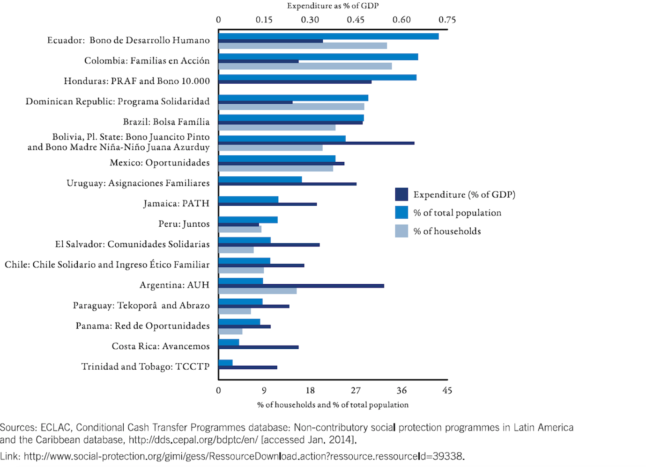

Non-health public social protection expenditure for People of working age, by national income 2010/2011 (% of GDP)
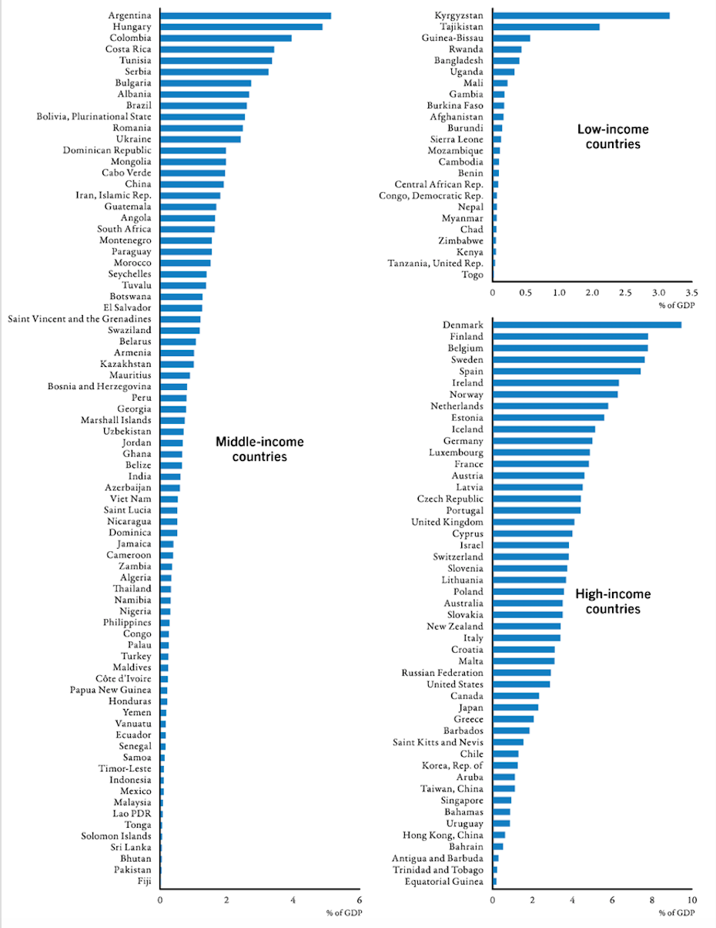

Non-health public social protection expenditure on pensions and other benefits for older persons, (2010/11) (% of GDP

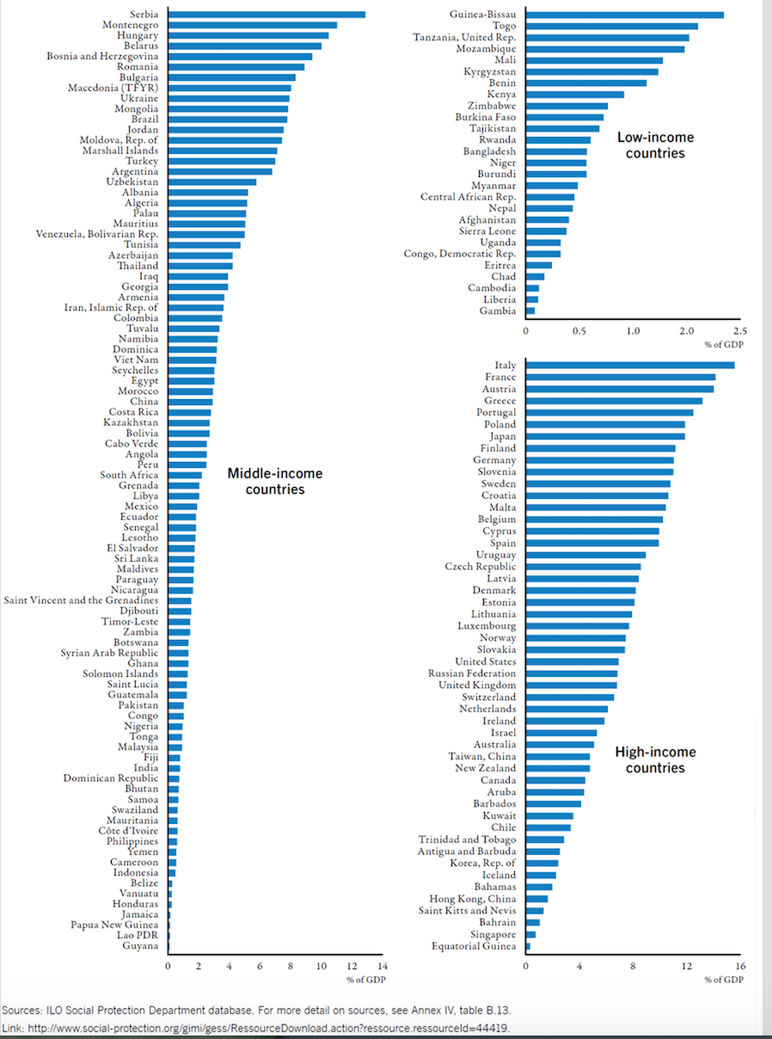

The Development of Social Protection in Jamaica
The church has possibly the longest history of involvement in social protection in Jamaica, arguably since the period of plantation slavery and it continues to be a major player in the field. After slavery, it was importantly involved in resettling ex-slaves on lands known as free villages, which were very important to the identity formation of the descendants of Africans enslaved in Jamaica and to their socio-economic survival as free people. It also crucially played a foundational role in the development of education, both as “civilizational” and in creating avenues for the social advancement of Jamaicans. Education continues to be subsidized by the church in 21st century Jamaica. The church also plays a role as a charitable entity and is therefore an important player in social protection across the nation.

The independent Jamaican state sought to build on the ideas of Norman Manley following his initiation of Jamaica Welfare in the colonial period. It emphasized “self-help activities among the rural people through popular education and the development of cottage industries and social welfare with emphasis on establishing cooperatives and programmes for youth advancement” (http://sdc.gov.jm/about-us/early-beginnings/). Jamaica Welfare later became the Social Development Commission, which has over time changed its understanding of community development to an emphasis on building community based organizations and structures that are expected to facilitate development within communities. The view of social welfare, has consistently emphasized self-help.

In the 1970s, under pressure from a popular and national movement for the democratization of the society, social protection was expanded through provision of free education and some measures of health care, housing, subsidized public transportation, three-months maternity leave for women, the passing of the Minimum Wage Act, generalized food subsidies and price controls and the development of a national school feeding programme. These measures were significantly rolled back or eliminated in the 1980s, taxes were imposed on food and commodities (General Consumption Tax) and targeted protection (food stamps) became the model of social protection. This shift was consistent with the consolidation of neoliberal economics. The public too retreated from its demands for protections – conditions moved from frequent protest involving the public to the professionalization of advocacy into non-government organizations. NGO’s began to significantly share the space for social protection with the decline in government efforts.

The Jamaican Social Protection Strategy
The Jamaican strategy defines social protection as:
the set of provisions that employ public and private initiatives, guided by state policies, to prevent, address, and reduce the risks of poverty and vulnerability brought about by lack of, losses or interruptions to income. Its objective is to ensure living standards above specified levels, through effective social, economic and labour market policies that support income security across the life span. (PIOJ 2014, 7)
This definition is more narrow than that of the ILO. It is not specifically interested in inequality, inclusion or the structural transformation of economies. It places poverty and vulnerability within the context of income security. This has implications for addressing the problem of persistent poverty in Jamaica, that is arguably a result of its economic structure – based in plantation and neoliberal economics and a middle class politics directed towards the interests of those in and above the middle class.
The SPS proposes a combination of social risk management, transformation social protection and a rights-based approach in guiding the development of social protection. It expects to rely on risk prevention as well as risk mitigation – to reduce the probability and the potential impact of risk. This would rely on providing support for market-based and informal risk management activities, including microfinancing. (PIOJ 2014, 21, 23). In the realm of transformative social protection, it emphasizes legislation and education (Ibid, 24). It defines the difference between a rights-based approach and social risk management as in the first instance, a push to correct social injustice and structural inequities in the society, and the second, making a contribution to “efficient development” (Ibid, 25). The Jamaican SPS does not find this balance. It adopts a limited view of Jamaicans’ understanding of their rights as a constitutional matter and argues that it should therefore be enshrined as a constitutional provision (PIOJ, 38). But this does not appreciate Jamaicans’ view of rights as entitlements that expand to the provision of water, proper roads, justice in policing, etc – which are evident in the claims made by protestors across communities.

Role of the State
The SPS argues that the role of the state “is to ensure that the market-based and private interventions considered necessary are in place” (PIOJ 2014, 40). It prioritizes:
(i) facilitating the establishment of market-based financial institutions, providing the enabling legal environment, ensuring their regulation and supervision, and helping facilitate the flow of information;
(ii) providing risk management instruments where the private sector fails (e.g. unemployment insurance) or individuals lack the information for self-provisions (myopia)”. (Ibid, 44, emphasis in original).
It also emphasizes equity in the provision of services.
In relation to the income segment of the social protection floor, the state’s roles are seen as “critical but less so than in relation to goods and services”. The state is to be regulatory – “using labour market legislation to promote decent work, adequate wages, pensions and occupational disability compensation” and to redistribute incomes “if market outcomes are considered unacceptable from a societal point of view”. Cash transfers are seen within the realm of income redistribution. (Ibid, 45).

Strategy Statements
The SPS takes a lifecycle approach in which there is a desired focus of the state at each stage of life. This focus emphasizes human capital development. For children 0-18, the strategy aims to: “promote optimal development of all children in all spheres necessary to ensure their well-being, and enhance the potential for their eventual productive engagement in the labour market.” (PIOJ 2014, 10) From birth, the Jamaican nation is expected to be concerned with the productivity of its children. For youth 15-24, it aims to: “Prepare young persons for adulthood by equipping them for employment and the attainment of income security, and the knowledge and attitudes necessary to lead responsible independent lives.” (Ibid). Added to productivity is that they be responsible actors. The strategy statement for those within the working age 15-64 years purports that “this population is the productive base of the economy, [the state must] ensure that persons of working age have opportunities for adequate employment and income, with conditions of work that are satisfactory for health and general well-being, and that capacity exists for the attainment of their income security” (Ibid, 62). While the emphasis remains on income security it is in this instance attached to well-being. For the elderly, the SPS hopes to: “Ensure access and opportunity for elderly persons to attain income security and an adequate living standard.” (Ibid, 11). The vision for the aged similarly represents a limited view of the well-being of citizens, based mainly on income as a determinant of quality of life. Within this vein, the SPS is meant to “rescue human capital from waste and harness it for high productivity and heightened consumption demand, plus facilitating management of risks such that shocks are mitigated and high risk investments can be readily made.” (Ibid, 16, emphasis mine). The end point is “national economic growth”. As such, the objectives of the SPS is first, “to enhance the prospects for economic and social development of Jamaica through a structured approach to the provision of social protection interventions”. It is also meant to:
- Provide the conceptual underpinning that will guide legislative and policy frameworks, resource mobilization, programming and service delivery, for social protection in the country
- Unite and orient the efforts of public and private actors and stakeholders in creating responsive programmes and initiatives for social protection, through the various types of interventions
- Ensure that vulnerable or disadvantaged population groups or individuals have recourse to a safety net facilitating basic income security and social services. (Ibid, 34).
Social protection is not treated as an end in itself. Rather, it is seen as “working in conjunction with relevant social and economic sectors to promote economic development by marshalling human and other resources towards equitable and productive ends” (PIOJ, 34).

Among the measures aimed at preparing children for the labour market is the promotion of “the discharge of parental responsibilities”. Actions would ensure that parents “know and discharge their obligations in relation to having and caring for children” (Ibid, 59). This type of imperative is consistent with a view that parenting is the problem of poverty. The SPS also seeks to protect their rights and ensure inclusion in opportunities for children with disabilities. In the main, these measures to be adopted do not seek to have children live full and meaningful lives as humans not attached to a productive end. Strategies for young people have a similarly limited view of quality lives – the main effort is towards connections to employment rather than a more holistic approach (see Ibid, 61).
The strategies for working people show an appreciation for the need to address working conditions in Jamaica and hence, the SPS highlights the need for legislation to protect workers including supporting a “decent work agenda”. It also promotes measures aimed at lifelong education, micro-finance and insurance to mitigate risks. (See Ibid, 62-63). There may, however, be an over-emphasis on the potential of market-based insurance and financial literacy, given the unavailability of resources for such investments among the poor. Other measures include temporary work projects and social and income transfers.

Strategies aimed at the elderly are not as limited as its statement in relation to that group. Measures seek to protect the rights of older people, promote community and family care and support, promote active aging, promote access to health care, public goods and services and extend cash and social transfers. (Ibid, 64-65)
The SPS sees social protection as impacted by cross-cutting issues: environmental factors, food and nutrition security, poverty reduction and crises and emerging vulnerabilities (65). The strategy sees as its main goal in relation to the environment to: “ensure that all residents have shelter, water, sanitation and physical access to goods and services that meet agreed standards of quality and security, in harmony with the natural environment “(66). No indication is made of what these standards might be. Further, there is an over-emphasis on housing standards as the basis of environmental concerns. There is no clear consideration of the threats to the island due to climate change, rising sea levels and the disappearance of beaches due to pollution and other factors. In a tourism dependent economy, and one in which whole communities depend on fisheries for their livelihood, the SPS does not sufficiently incorporate these concerns. There is some attention to waste disposal and livelihood practices but broad environmental concerns are not deeply integrated. (see 66-67)

In the area of food security, the SPS should “ensure that a sufficient quantity of nutritious food is available through increased domestic production and sustainable importation, and that all individuals have access to resources to acquire adequate and affordable food at all times” (67). To this end, it looks to an expansion of production beyond farmers to schools, communities and households and expects to build networks between food providers and the needy.

With regard to poverty reduction, the strategy will be to “Promote the attainment of living standards of persons or households above levels that are considered as being in poverty based on accepted national criteria” (68). This goal is aligned to all aspects of the strategy statement and is seen to be attached to prospects for economic growth.

Specific responses to crisis and emerging vulnerabilities will be treated by protecting “residents from the worst effects of national or sub-national crises (originating from any source) that threaten their socio-economic well-being; engender proactive approaches to foreseeing emerging social security needs and facilitating appropriate responsive mechanisms” (70). Responses are seen to rest on long term planning and preparation and immediate relief support in the event of crisis.

The execution of these measures is to achieved by a Social Protection Committee with networks across the island and within the public and private sectors and with NGOs. It is expected that these networks will also form part of the financing of social protection. Financing the strategy is also based on an expectation that families, communities and international development partners will participate in facilitating efforts (88). Outside of usual sources of financing, the strategy proposes:
- major funding changes envisaged are the National Insurance and Public Sector Pension (PSP) Schemes both of which are unsustainable under current conditions. Both schemes are under revision to make their funding sustainable, primarily by aligning contribution levels with benefits; this involves raising the contribution levels for the NIS while making the PSP contributory.
- establishing a link to the NIS and NHT that would make the scheme [for unemployment insurance] viable and attractive. NHT refunds [sic] could be transferred as a lump sum to individuals’ NIS…The government could also provide a risk-pooling fund using funds sequestered from existing lottery flows (91).
- [To] reintroduce tuition fees at secondary level with fee waivers for those who cannot afford to pay. (92)
- Include Local Property Taxes for regular maintenance for potable water and sanitation and for shelter, obtain labour inputs from able bodied beneficiaries to offset costs to the state. (92)
- [To] move away from universal system both for tuition and school feeding programmes (93)
- move towards a national health insurance programme, starting with the NHF acting as a purchaser and financier of health care for the most vulnerable population, using tax revenue, that is, its present source of funding plus additional resources from the Consolidated Fund. (94)
As justification for the reintroduction of tuition in secondary education, the SPS states that an examination of the impact of the policy of no user fees in the health sector revealed that it “did not guarantee universal access to care, particularly for the poor” (93).

To fund the social protection floor, the SPS recommends better tax collection, a new levy on gun licenses, targeted access, funds from CHASE, funds from the proceeds of crime and the casino industry and fines for breeches of environmental protection laws and regulations (94). Those new measures that will require additional funding are:
Promoting greater access to, and assimilation of information and services in health and nutrition, for pregnant and lactating women who are clients of the public health sector; Instituting social pensions for elderly in greatest need; Case management by targeting social worker interventions to pertinent households; Provision of shelter solutions for persons living in housing below acceptable standards and; Expanded public education programmes. (95-96)

Conditional Cash Transfers
The ILO contends that cash transfers are an insufficient means of providing income security for children and families. It argues instead that measures are needed to address well-being including health, education, care and child protection, attention to employment policies, and the availability and accessibility of quality childcare services and early childhood education, (ILO 2014, 23). It is also contended that conditionalities can themselves be damaging to families. The ILO points out that when beneficiaries do not meet the specified conditions, sanctions result in the suspension or termination of benefits. (Ibid, 19). Because such transfers are geared to those at the very bottom, their poverty itself often functions as a deterrent to meeting conditions.

Saad-Filho argues that conditional cash transfers are typical of neoliberalism and its type of poverty alleviation. Typically, he says, the focus on extreme forms of (absolute) poverty, and (conditional) cash transfers (CCTs) are the main measure. (Saad-Filho 2016, 73). CCTs are expected to have an intergenerational impact in so far as they should change behaviours of beneficiaries. Conditionalities are expected to push families to make “better choices, especially higher investment in their children’s human capital” (Ibid, 74). In the Jamaican case, PATH benefits are attached to school attendance. The SPS is invested in an idea of good behaviour as part of the rationale for cash transfers. It claims, “the use of conditional cash transfers to promote behaviour change has further engendered a close relationship between SP and these sectors, with positive results in service usage in many countries including Jamaica” (PIOJ, 33). It is noted that:
the condition for receiving the Programme of Advancement through Health and Education (PATH) benefits of stipulated levels of school attendance has contributed to the desired behaviour change of improving school attendance for PATH recipients. However, it has also brought to the authorities’ attention problems on the school side as well as other obstacles to school attendance such as transport costs. Moreover, a spin off has been the strengthening of links between home, school and the SP sector as the interaction levels have increased. It may therefore be argued that the positives gained from educational conditionalities for children appear to outweigh the negatives. (PIOJ 2014, 48)
Women are especially affected by conditionalities given their over-representation in care giving in families. It is they who must carry-out conditionalities, often taking more of their time and expenses, including in “programme-related tasks (for example, they are required to participate in information sessions or training and awareness activities). (ECLAC-ILO, cited in Saad-Filho, 82).

Saad-Filho asserts that conditionalities are meant to support the market and hence better choices include “stable wage employment or micro-entrepreneurship, and higher investment in human capital, including education, health and avoidance of child labor, while penalizing “bad” behaviors like leisure, begging, drinking or prostitution” (75). He asks: Why are conditionalities necessary if not to reproduce neoliberal economics? He argues that unconditional programs are as effective as CCTs, and that economic growth, job creation and rising minimum wages have a much greater impact than CCTs on the welfare of the poor. While they, give funds to the needy they do not address the causes of deprivation and inequality (77). They are also “too small to support growth and macroeconomic stability, challenge the reproduction of poverty or transform the life chances of the poor” (78). Administrative costs of targeting also makes less resources available to the poor.

Alternative Economics
Limitations of CCT’s can be seen within the frame of limited approaches to economics. Saad-Fihlo suggests that the implementation of pro-poor universal social policies are key to a broader pro-poor development strategy. (Saad-Filho 2016, 68) He rejects the neoliberal view, which sees poverty as caused by exclusion from labor or commodity markets, and market-led growth as the route to eliminating poverty. He contends that the “overall impact of growth on poverty and inequality depends on the structure of the growth process and the mediations of social policy”. (Ibid, 69). Improvements in poverty and inequality Saad-Filho argues, are “closely inter-related, and they require specific policies rather than “growth” in general, or social policy interventions merely at the margin” (Saad-Filho, 72). Indeed, poverty alleviation cannot be achieved without attention to inequality. Saad-Filho suggests that high levels of inequality make it more difficult to address poverty. (84)

In that context, Saad-Filho presents an alternate view of poverty and the role of social protection services. It is not meant to “rescue human capital from waste and harness it for high productivity and heightened consumption demand” but rather the case for pro-poor policies is because of the value of equity in economics, human development and the need to deal with human deprivation. Rather than a limited view of minimal income transfers, governments can rely on measures identified by the ILO, such as: reallocation of government expenditure, increasing tax revenues, expanding social security contributions, reducing debt and debt servicing, tapping fiscal reserves, targeting illicit financial flows, increased aid, more accommodating macroeconomic framework (ILO 2014, 153). Further, there is according to Molyneux, a “growing recognition of the need to ease budget constraints and allow for an increasing degree of deficit spending, especially to support socially relevant investments and employment-generating economic growth”. Finally, a movement away from targeted programmes and towards universal provisions is desirable. Universal programs can include “public education, training, health, housing, water and sanitation, transportation, parks and public amenities, environmental preservation and food security, affordable clothing and so on” (Saad-Filho 2016, 85).

Conclusion – The Way Forward
There is significant need for the discourse around social protection to shift from a view of human beings as capital, if the well-being of Jamaica’s population is to be adequately enhanced. It is proposed that such a view limits the vision of social protection and by extension constrains the possibilities for addressing the problem of poverty in the long term and for enhancing people’s lives just because they are human. Given the breadth of poverty in the nation, not merely as it relates to those people measured as existing below the poverty line, the urgency of such a view comes into focus. At stake is the fact that poverty will not be addressed in the short term and not by measures that attach social protection to individuals’ capacity to contribute to production and growth. Alternative economics needs to be explored. Further, while the nation lives with poverty, the problems associated with it go beyond the lived realities of those deemed poor and are social as well as economic. Associated problems include exclusion, alienation, low productivity and high levels of violence, which in the Jamaican case result not only from poverty but from inequality. This suggests that a more wholesale approach to poverty needs to be taken that addresses the quality of people’s lives and their access to opportunity. In terms of advocacy work, a push is needed towards:
- rethinking the meaning of development to emphasize not what currently exists in Europe and the United States but towards the type of societies that emphasize the value of human life as life not as capital. This means moving away from conditional income transfers as a solution to poverty and seeking instead improved quality of life including leisure, access to quality education, justice, respect, meeting basic needs as norms.
- implementing pro-poor macro-economic measures that integrate the problem of poverty and inequality into the structure of the economy. Structural transformation of the Jamaican economy would address the limited resource orientation of the SPS and the Jamaican state. The implication here is that the state needs to be pushed to change its thinking about poverty, inequality and its role in bringing about change in the interest of the majority of Jamaicans.

Social Protection and Support Services in Jamaica
The Jamaican Social Protection Strategy defines social protection as:
the set of provisions that employ public and private initiatives, guided by state policies, to prevent, address, and reduce the risks of poverty and vulnerability brought about by lack of, losses or interruptions to income. Its objective is to ensure living standards above specified levels, through effective social, economic and labour market policies that support income security across the life span. (PIOJ 2014, 7)
In mapping the provision of social protection and support services existing in Jamaica, it is found that organizations fall into groups that:
- provide food, shelter and other material needs of living for the poor;
- provide support services for vulnerable persons who are made vulnerable due to their status as women, due to sexuality or due to physical and mental disability;
- income support is given mainly by the state to those deemed poorest in the society;
- the state also provides support in the provision of health insurance and care;
- provide psychological care for persons troubled by violence and other experiences of trauma and unable to secure private services;
- health and other care for persons living with HIV;
- care for persons affected by drug addiction;
- seek protection of human rights and;
- give financial assistance for education, mainly up to the secondary level.
There are significant charitable works carried out by the Church in Jamaica however, the list below does not incorporate those activities as it is assumed that churches are involved in charitable activities that promote the well-being of their members and their community. Several private foundations operate in Jamaica which are not elaborated on in this list. These include: Carimed Foundation, NCB Foundation, Sandals Foundation, Denoes & Geddes Foundation, Jamaica National Building Society Foundation, Issa Foundation Ltd, Digicel Foundation, Usain Bolt Foundation, Scotiabank foundation and Lime Foundation. There are also children’s and old age homes such as the SOS Children's and the Golden Age Home that serve as shelters across the island.

Organizations involved in Social Protection and Support Services in Jamaica

Name of Organization | Bob Marley Foundation
Category | Financial Assistance
Type of Service | Financial assistance to school aged children at the primary and secondary level. Aged 6-18
Description | The Bob Marley Foundation is a charitable foundation with the goal of providing assistance to communities in need. One such area of assistance is financial support in the form of scholarships at the primary and secondary level, financial assistance for uniforms, books or lunches for students.
Name of Organization | Centre for HIV/AIDS Research,  Education and Services (CHARES)
Category | Health Services
Type of Service | Medical care to persons infected and living with HIV/AIDS.
Description | CHARES provides free medical management, social services and counselling for persons infected and affected by HIV. Medication is also provided through the Global fund subsidy.
Name of Organization | Centre for the Advancement of  Individuals with Special Needs (CASANI) – Granville, St. James
Category | Children with Disabilities & Exceptional Abilities
Type of Service | Centre catering to children with special needs.
Description | CASANI offers diagnostic testing, counselling and referrals for individuals with special needs. Aged 5-12

Name of Organization | Child & Adolescent Mental Health Services  (Child Guidance Clinic) Kingston, St. Catherine, St. James, St. Mary & St. Thomas
Category | Counselling & Psychological Intervention
Type of Service | Medical care for children with physical, emotional and psychological concerns.
Description | Child Guidance Clinic administers assessment and counselling of children with developmental, behavioural, medical or psychological concerns. Birth-18
Name of Organization | Child and Family Clinic. UHWI
Category | Counselling & Psychological Intervention
Type of Service | Medical care for children with physical, emotional and psychological concerns.
Description | Child and Family Clinic provides assessment and counselling of children with developmental, behavioural and psychological concerns. Birth-12
Name of Organization | Child Development Agency. Islandwide
Category | Care & Protection
Type of Service | Facilitates care and protection for minors who become wards of the state.
Description | CDA is a Government agency that provides care and protection of children. CDA is committed to children who have been abused, neglected or made orphans. CDA facilitates institutional placements (children’s homes), supervision, foster care placement, adoption and home and family services. Birth - 18
Name of Organization | Children First
Category | Care & Protection
Type of Service | Remedial and skills training school for children, also educates  on sexual related issues.
Description | Children First administers remedial education and basic skills training for youth aged 10–24 years. The Caribbean Youth Empowerment Programme  is another programme offered which targets those 17–24 years to be trained in  a particular skill in collaboration with HEART. Children First also facilitates the ‘Bashy Bus’ programme which utilizes peer educators who travel to schools and communities to educate individuals on sexual related issues. Aged 10-24
Name of Organization | Children’s Coalition of Jamaica, Kingston
Category | Care & Protection
Type of Service | Membership Non-Government Organisation (NGO) catering to the wellbeing of children.
Description | NGO interested in the wellbeing of children. Children’s Coalition partners with other NGOs in order to facilitate various projects such as the development of children’s and parents’ help lines, promotion and identification of areas of needs in children homes and public education and advocacy on children issues. Child participation in the development of policies at the community and government levels are also encouraged. Birth – 17.

Name of Organization | Combined Disabilities Association, Kingston
Category | Children with Disabilities & Exceptional Abilities
Type of Service | Agency which advocates for the rights of persons with disabilities.
Description | Combined Disabilities deals with advocacy matters pertaining to rights and equity of the disabled. They also provide economic and emotional support where necessary. All ages.
Name of Organization | Community for the Upliftment  of the Mentally Ill (CUMI), St. James
Category | Health Services
Type of Service | Rehabilitative and psychological support for those mentally ill.
Description | CUMI offers a rehabilitative day centre for the mentally ill and a night shelter for the homeless. They also offer psycho educational assessment and care for children whose parents are mentally ill. CUMI also manages a children’s programme targeting at risk youth, in order to give them a sense of empowerment and positive encouragement through the assistance of a psychologist. Ages 5 & up
Name of Organization | Dare to Care, St. Catherine
Category | Care & Protection
Type of Service | Residential care for children living with or affected by HIV/AIDS.
Description | Dare to Care provides residential care for children living with HIV/AIDS. There is also a school on the grounds for children which offers academics at the pre- school to secondary level. Ages 2 – 18 years
Name of Organization | Dispute Resolution Foundation of Jamaica, Kingston
Category | Counselling & Psychological Intervention
Type of Service | Mediatory body which provides training on conflict resolution for young people.
Description | The Dispute Resolution Foundation of Jamaica is a mediation office that handles disputes and conflicts involving young people. The Youth Department arm of the DRF has developed the ‘Suspension Intervention Programme’, for students who have been or are about to be suspended from school. Students attend training sessions on conflict resolution, anger management, mediation and restorative practices at any of the six Peace and Justice Centres for the duration of their suspension.  Centres: Trench town Peace and Justice Centre, Eastern Peace and Justice Centre, The Peace Centre, Spanish Town Peace and Justice Centre, Flankers Peace and Justice and the Clarendon Peace and Justice Centre. Ages 10-19

Name of Organization | Family Court, Kingston, St. James, Hanover
Category | Care & Protection
Type of Service | The family court adjudicates all matters relating to the family.
Description | The Family court is responsible for all legal proceedings relating to family matters except divorce. Legal matters handled by the family court include custody arrangements and paternity matters.

Name of Organization | Drug Abuse Secretariat, Islandwide
Category | Health Services
Type of Service | Agency responsible for information and educational services related to drug abuse and addiction.
Description | Drug Abuse Secretariat functions as an information centre with resources on substance abuse, treatment, rehabilitation and prevention, training of community advocates and referral services for drug dependents. Counselling services are also provided for drug users and addicts. Field officers conduct islandwide visits to various institutions providing educational services and workshops on drug related issues as well. All ages
Name of Organization | Edgehill School of Special Education, St. Ann
Category | Children with Disabilities & Exceptional Abilities
Type of Service | Educational service for children with learning disabilities.
Description | Edgehill School of Special Education offers academic programmes for children with intellectual disabilities. Programmes offered include curriculum at the primary and secondary level such as GSAT CXC or the National Vocational Qualification Certificate depending on the each child’s academic ability. Ages 7-18
Name of Organization | Father’s Incorporated, Kingston
Category | Counselling & Psychological Intervention
Type of Service | Support group for fathers in Jamaica.
Description | Fathers Inc is an organisation devoted to the positive development and support of the expecting or present Jamaican father. Services include the provision of workshops, seminars and conferences on positive fatherhood.
Name of Organization | The Foundation for International  Self Help Development (Ja.) Ltd (FISH)
Category | Health Services
Type of Service | Medical services through clinic for all persons.
Description | FISH operates a clinic that provides a full range of high quality general health care, dental and eye care. FISH also provides pharmaceutical services.
Name of Organization | HIV/STD Control Programme, Islandwide
Category | Health Services
Type of Service | Programme educating children, adolescent and adults on healthy lifestyle and safe sexual practices.
Description | The HIV/STD Control Programme trains and advises children, adolescents and adults on matters relating to HIV/AIDS and STIs in order to maintain a healthy lifestyle.
Name of Organization | Hope for Children Development Company, Kingston
Category | Care & Protection
Type of Service | Organisation that offers educational, social and emotional support for families and children.
Description | Hope for Children is a child and family support organisation that offers services such as educational scholarships and grants, school placements, referral services and counselling. The Hope for Children offers support for youth activities such as drama, youth clubs and leadership training.
Name of Organization | Hope for Children Development Company
Category | Care & Protection
Type of Service | Organisation that offers educational, social and emotional support for families and children.
Description | Hope for Children is a child and family support organisation that offers services such as educational scholarships and grants, school placements, referral services and counselling. The Hope for Children offers support for youth activities such as drama, youth clubs and leadership training. Ages 4-12
Name of Organization | Independent Jamaica Council for Human Rights (IJCHR), Kingston
Category | Care & Protection
Type of Service | Advocacy agency for matters related to human rights.
Description | IJCHR disseminates public education and advocacy for human rights. Limited legal assistance may be provided for persons whose fundamental rights and freedoms have been breached.
Name of Organization | Ionie Whorms Inner-city Counselling Centre, Kingston
Category | Counselling & Psychological Intervention
Type of Service | Counselling Organisation that focuses on person with drug, drug trafficking and HIV/AIDS related concerns.
Description | Ionie Whorms provides counselling services particularly for persons affected by substance abuse, drug trafficking and HIV/AIDS related issues. They also provide support for persons in and around the community who face other social, emotional and psychological issues. Referrals are also provided to other agencies where necessary.
Name of Organization | Jamaica AIDS Support for Life
Category | Care & Protection
Type of Service | Support agency for children infected or living with AIDS/HIV.
Description | Jamaica AIDS Support offers several services such as counselling, school fee assistance, medication and foster parenting for orphans and other children made vulnerable by HIV/AIDS.

Name of Organization | Food for the Poor
Category | Charity
Type of Service | Distributes aid to the needy
Description | Provides emergency relief aid and programmes in the areas of housing, food, medical, water, sanitation, education, agriculture, outreach and micro-enterprise.

Name of Organization | Grace & Staff Community Development Foundation
Category | Care & Protection
Type of Service | Community-based programme offering educational and social services for children at the primary to the tertiary level.
Description | The Grace & Staff Community Development Foundation facilitates educational assistance and services at the primary to tertiary level. These services include scholarships, school fee assistance, remedial classes and homework centres in three communities. They also provide counselling services through a mentorship and career development programme.
Name of Organization | Parish AIDS Committees, Islandwide
Category | Health Services
Type of Service | Educational Service on all matters related to safe sexual practices.
Description | Parish AIDS Committee posits health promotion related to HIV/AIDS issues. Focus is placed on reducing stigma and discrimination and providing psychosocial support to persons infected or affected by HIV. They facilitate educational seminars, workshops or advocacy sessions throughout communities.

Name of Organization | Jamaica Association for the Deaf JAD
Category | Children with Disabilities & Exceptional Abilities
Type of Service | Provides educational, diagnostic and social services for persons with hearing impairments.
Description | The JAD offers three different services for persons with hearing impairments. The educational service offered includes early stimulation, vocational and academic education at rural and urban locations. The hearing service offered includes assessment and diagnostic interventions as well as the administering of hearing AIDS. The social service offered facilitates skills training/career development and Counselling & Psychological Intervention. Pre-school to adults
Name of Organization | Jamaica Council for Persons with Disabilities, islandwide
Category | Children with Disabilities & Exceptional Abilities
Type of Service | Government based organisation for the advocacy of persons with disabilities.
Description | JCPD is a department of the Ministry of Labour and Security. The JCPD registers all persons with disabilities throughout the island. Their main mission is advocacy for persons with disabilities at the financial, social, emotional and physical levels.
Name of Organization | Jamaica Red Cross
Category | Health Services
Type of Service | Charity based organisation involved in community development and improvement for all age groups.
Description | The Jamaica Red Cross hosts a wide range of programmes for youth, individuals and families. These programmes include Red Cross Cadets, Red Cross youth groups, parenting workshops and conflict and mediation training courses.
Name of Organization | Jamaica Society for the Blind
Category | Children with Disabilities and Exceptional Abilities
Type of Service | Diagnosis and rehabilitation of person with visual impairments.
Description | JSB provides diagnosis and rehabilitation of persons with visual impairment including referral services, adjustment to blindness programmes and a library service.
Name of Organization | The Jamaican Association on Intellectual Disability, Islandwide
Category | Children with Disabilities and Exceptional Abilities
Type of Service | Organisation that manages schools for children with intellectual disabilities.
Description | The Jamaican Association on Intellectual Disability manages five main schools for children with intellectual disabilities. The schools are located in the parishes of Spanish Town, Kingston, St. Ann, Westmoreland and Manchester. These schools also have several learning centres throughout the island. Ages 6-21
Name of Organization | Jamaica Network of Seropositives (JN+)
Category | Health Services
Type of Service | Counselling services and support for persons infected and affected by HIV/AIDS.
Description | JN+ provides face-to-face and telephone counselling for persons infected and affected by HIV/AIDS. JN+ also advocates on matters related to discrimination and stigma of persons affected by HIV/AIDS. JN+ also provides peer support in the form of support groups for affected persons. Ages 16 & above
Name of Organization | Jamaicans for Justice
Category | Care and Protection
Type of Service | Monitoring of human rights violations and social injustices.
Description | Jamaicans for Justice offers training, legal aid, public education, community outreach programmes and the monitoring of human rights violations for all citizens of Jamaica by agents of the state.
Name of Organization | (Randolph Lopez School of Hope) Elleston Road, Franklyn Town
Category | Children with Disabilities & Exceptional Abilities
Type of Service | Educational service for children with learning disabilities.
Description | Learning Centre provides schooling for children with intellectual disabilities such as mild to moderate mental retardation and other learning disabilities. Counselling and psychological services are also offered where necessary. Ages 6-16
Name of Organization | Missionaries of the Poor
Category | Charity
Type of Service | Outreach and relief to the needy
Description | Runs a shelter for the homeless destitute, is involved in consciousness raising about the plight of the poor, runs a prisoner rehabilitation programme
Name of Organization | Mustard Seed Communities
Category | charity
Type of Service | shelters
Description | Provides residential care to over 400 children and adults in 13 homes across Jamaica. The populations we care for comprise the most vulnerable groups in Jamaican society: children and adults with disabilities, children affected by HIV/AIDS, and young mothers in crisis.
Name of Organization | National Health Fund
Category | Government
Type of Service | Health benefits
Description | Provides financial assistance for prescription drugs and in the treatment and care of specified diseases – makes fixed payment towards prescription drugs and education on managing chronic diseases.
Name of Organization | Programme for the Advancement of Health and Education (PATH)
Category | Government – social welfare
Type of Service | Income safety net
Description | Provides conditional cash transfer to the most needy and vulnerable in the society.
Name of Organization | Salvation Army
Category | charity
Type of Service | Disaster Relief
Description | Provides disaster relief, trauma counselling and emotional support, food, basic commodities and material distribution to the poor, financial grants, child care and reconstruction in major disasters
Name of Organization | Women’s Centre of Jamaica Foundation
Category | Outreach to adolescent mothers
Type of Service | Education and Support to Adolescent mothers and their family and baby’s fathers
Description | Offers counselling, academic education to young mothers, education on child care to young mothers and fathers, support and referral services and training to school drop-outs or mothers who cannot return to school. Ages 17 & under.
Name of Organization | Women Incorporated (Crisis Centre)
Category | Women’s support
Type of Service | Counselling, shelter and education
Description | Offers crisis counselling, referral services and a 24 hour hot line. Addresses rape, incest, domestic violence, domestic crisis and sexual harassment. Hosts a hostel and training centre for young women. Seeks legislative reform and consciousness raising on women’s issues.
Name of Organization | Women's Resource and Outreach Centre Limited
Category | gender equality and the empowerment of women and girls, and supports boys and men
Type of Service | Advocacy, skills training, community outreach in underserved communities
Description | Skills training for youth, counselling services, community capacity building; and Research, Communication and Advocacy on gender equality including gender based violence.

Barriers to Access to Existing Social Protection Services
Groups surveyed in this research gave a view of challenges to accessing social services in Jamaica. (See Appendix A for methodology). Survival strategies were largely similar across groups surveyed. Participants spoke of hustling, receiving gifts, and social protection benefits as their means of making ends meet on a day to day basis. Notably, middle income participants (of which there were few) were less likely to speak of hustling as a means of survival, especially once employed. Hustling ranged from working odd jobs to selling things including personal items:
“I do day’s work when I can get it”
“Sell clothes”
“Raise chicken”
“Sell chemicals”
“Sell hair”
“Do eyebrows or hairdressing. I never get any training but you help out a friend and them will give you a 5 bills or suh”

“Sewing”
“Higglering downtown”
“Sell ice cream”
“Sell juice”
“Have a shop at the house”
“Sometimes you even have to beg”
“Road work”
“If it really bad I will even take things (I own) out my house and sell”

Gifts included money, clothes, groceries, remittances, and furniture from a variety of sources:
“Baby father”
“Partner
“Hustle man (admirers)”
“Older children here”
“Family here and overseas”
“Close friends”
“People outside the community”
“Neighbours”

Social protection benefits which aided in their survival included PATH, financial and treatment assistance from JASL. Key informants noted a wide array of social protection benefits are made available by the Government of Jamaica, NGOs and non-profit organisations. LGBT and PLHIV populations noted opportunities to access social protection are extensive and varied. Services primarily range from those for the poor (general population) and take the form of financial, training/education assistance, medical and social assistance, to those that are designed specifically for key populations (LGBT, PLHIV, sex workers, persons with disabilities) which take the form of services such as advocacy, HIV treatment, pharmaceuticals and a redress system for reported cases of stigma and discrimination.

Diagram X provides a summary of the social protection benefits available to the general population while Diagram XX provides a list of benefits available to our population of interest.

Diagram X: Types of Benefit Available to General Population

Diagram showing Social Protection Benefits Available to LGBT & PLHIV

Type of Services
- Advocacy
- Care packages
- Financial assistance
- HIV treatment
- Medical assistance
- Redress system
- Referrals/go between

Service Provider
- J-FLAG
- JASL
- JN Plus
- MOH

BARRIERS TO ACCESS
Though the research revealed the wide availability of social protection services, it also uncovered that the incidence of access among the key population in our study was low, resulting in an underutilization of some programmes. Of note, the research revealed the pervasiveness of challenges hinging on perception. the extent to which this was so was unclear however.

Main reasons for poor access were identified as follows:
  - Discrimination and stigma
  - No, low and inconsistent information about social protection
  - People stick to what they know and are comfortable with
  - Eligibility criteria unclear for some

Discrimination and Stigma
- Discrimination and Stigma is a concern but not as prevalent
For LGBT and PLHIV participants, discrimination and stigma continue to be major barriers to access, though according to study participants, these are not as grave a concern as with previous years. Some participants alluded to feeling/experiencing greater trust, tolerance and inclusion, as evidenced in the healthcare system where healthcare workers were said to be demonstrating greater tolerance to the LGBT and PLHIV community. Notably, for every case of discrimination and stigma mentioned there were 4 or 5 cases of non-discrimination and stigma noted among study participants.

- Security guards in healthcare system main provocateur. Comprehensive Clinic a major concern
However, security guards in the healthcare system, namely those at the Comprehensive Clinic and to a lesser extent the clinic at Kingston Public Hospital, still posed a major problem. The quote below was a typical cry among those LGBT and PLHIV participants who had experienced or heard of any such incidences at Comprehensive Clinic:
“From the security guard get yuh paper, him scorn yuh. Then by the time you reach down him friend and everybody know yuh business. And then sometimes him call yuh names”
One service provider added:
“One of our clients experienced discrimination at KPH where she went to do a procedure and in front of everybody on the Ward the nurse said she won’t allow her to do the procedure because she didn’t want her to salt up everybody on the Ward. So we had to intervene and contact the Minister and newspaper. By the following week our client did the procedure.”
On the contrary, the quality of service received from other public health facilities was reported to be generally pleasant.

The layout of the Comprehensive clinic also lent itself to issues of discrimination and stigma:
“Once people see that you going to that section of the clinic they know you are PLHIV. So everybody know your business. They need to mainstream it so people won’t know your business because as soon as they realise they start to treat you differently”

- Perceived discrimination/stigma perhaps just as real and prevalent
What was not clear was how often the reports were based on perceived versus real discrimination/stigma. Two of our key informants alluded to the fact that quite of bit of the instances reported pointed to perceived discrimination/stigma:
“I know there are instances of discrimination and stigma. We have dealt with it first hand on behalf of our members. However sometimes it’s perceived. What happens is that the customer service at these locations is generally bad and the staff members aren’t trained to answer people in a pleasant manner and that is the case even for the general population. So what happens is that our members go and get the same treatment and think it’s about them when it’s just about poor customer service.”

- Some private doctors displaying biases
One J-FLAG group participant mentioned experiencing discrimination/stigma when she visited a private psychologist to treat her depression. The group participant reported that once she had disclosed her orientation the doctor no longer showed concern for her depression. Instead the doctor became unduly concerned about her sexual preference.

- Issues of discrimination/stigma also occurring within community
Internal discrimination was also evident. One PLHIV male remarked:
“I came to a meeting and the guy in the meeting was a PLHIV MSM like me and mi did fraid. Mi did fraid. Mi did fraid. Mi did fraid bad bad bad. Cause when dem round dem friend out a road dem will tell people yuh business. And when dem done talk yuh will tink seh nutten nuh duh dem but everything duh you. Me fraid a dem cause dem will cause problem fi yuh mek people waan all stone yuh and cuss yuh”
Others in the focus group and key informants agreed that this kind of scenario was more commonplace than they would have liked.

No, Low and Inconsistent Information about Social Protection
- Insufficient information out in the market
Invariably, there was little or no information being disseminated by social protection service providers. The main cause for concern here was that little marketing is done within the wider population; advertising and public relations efforts are almost non-existent.
“One of the things I wish we would do as providers is market ourselves more. Our (collective) marketing budgets are usually too small for us to advertise in mainstream media much less to do so regularly. We generally have limited resources. So even if we had the budget we wouldn’t want to spread information as this would put a strain on the system.” (NGO Informant)
This resulted in misinformation, a concern corroborated by focus group discussions and key informant interviews. For example, the majority of PATH beneficiaries believed that PATH merely provided funds for lunch and bus fare. Food for the Poor was thought to only provide housing, while it was said that JASL was a HIV clinic open only to PLHIV. Yet research revealed that the benefits under these programmes were far more in some instances.

Table: Services offered under PATH, Food for the Poor, JASL

Furthermore, insufficient information is shared at the point of contact between applicants/beneficiaries and employees of the social protection provider.
“When you go to the office they don’t give you information.” (PATH beneficiary)
“When you call or go to the PATH office some of them don’t really say anything is like you’re bothering them” (PATH beneficiary)
“When you call they don’t like talk on the phone.” (PATH beneficiary)

This insufficient information resulted in the majority of participants being unaware of the benefits for which they could apply, or were entitled to as beneficiaries. In some instances beneficiaries conveyed surprise as they listened to other focus group participants describe the kind of services they had benefited from as recipients of J-FLAG, JASL or PATH:
“J-FLAG and JASL do that? I didn’t know” (J-FLAG employees and volunteers)
“I didn’t know JASL does that.” (JASL beneficiary)
“I didn’t know JASL offers all of that. I thought they only did HIV testing. I thought they really just catered to PLHIV” (J-FLAG employees and volunteers)
“Is true when I talk to my friend they tell me bout somethings that dem get from PATH but me neva know dat dem duh dat” (PATH beneficiary)

- Inconsistent information shared by providers
Inconsistent information is being shared at point of contact. This was particularly true for PATH:
“Sometimes you talk to one person and they tell you one thing and then the next person tells you another. You have to wonder if they work the same place” (PATH beneficiary)

- Word of mouth not a valid source of information
Low, no or inconsistent information has resulted in some persons turning to inappropriate channels, primarily word of mouth, for information on eligibility, types of benefits available and application processes. Word of mouth often came from a trusted source, ones they believed to have all the information necessary to make an informed decision. Unfortunately these very sources sometimes held biases and negative perceptions, particularly with respect to PATH:
“Me hear say dem only give dem friend so mi nuh bodda apply (to PATH)”
“I hear it take long and dem ask one bag of question so I don’t bodda wid it (PATH)”

LGBT and PLHIV (Like Gen Pop) Stick To What They Know and Are Comfortable With
- For most LGBT and PLHIV knowledge of social protection limited to J-FLAG and JASL
For the majority of LGBT and PLHIV study participants, knowledge of social protection benefits was limited to the organisations they often interacted with such as J-FLAG, JASL and public health facilities. This was not surprising as participants appeared to prefer the idea of not having to go outside of the confines of their LGBT and/or PLHIV community. For them, this was convenient, affordable (having implications for costs associated with medication, testing, treatment, travel etc.), safer and more secure. As such, many looked forward to being able to access the various services from providers within their network – J-FLAG and JASL – and explained that they look forward to the day when they will no longer have to go outside of the network.
Interestingly, many of the services these participants require are offered by JASL. Yet only one J-FLAG employee and two JASL beneficiaries in our focus groups were aware of this. This is even more alarming given the level of collaboration that takes place between the two organisations.
- Most LGBT and PLHIV not looking outside of J-FLAG and JASL for social protection
LGBT and PLHIV participants made little attempt to garner information about other social protection benefits (such as PATH), and interacted with public health facilities as little as possible. Several admitted to having heard of PATH, Food for the Poor or the National Health Fund but few had very little experience with same. On the whole, the community stuck with what they knew and were comfortable with. This however was not peculiar to LGBT and PLHIV as it mirrored behaviour of the general population.
“No I never really check out anything else. I hear about it but I just stick with PATH”

Eligibility Criteria Unclear For Some
Low, no and inconsistent information also resulted in the population being unsure about the eligibility criteria for the various social protection programs. This too was perpetuated by the inaccurate information shared by their trusted sources. In the end, the perception that some of these services was not for them was highlighted:
“I won’t get through. My friend seh if you have fridge and TV you can’t get PATH” (JASL beneficiary)
“Isn’t JASL just for persons who have HIV?” (J-FLAG volunteer)
“NHF for people who old” (majority)
“I hear that is dem friend dem give it to and me can bodda wid dat cause dat mean me nah get it cause me and none a dem a friend” (JASL beneficiary about PATH)
“I wouldn’t even know how to apply for that so I don’t bother so even if I knew about it I probably wouldn’t bother” (J-FLAG volunteer)

RECOMMENDATIONS
- Improved dissemination within wider population, across organisations and at point of contact with applicants and beneficiaries
- Extending training in the healthcare system to security guards and other non-medical staff
- Arming peer navigators with information about PATH, NHF, Food for the Poor and JASL
- Intensive marketing campaign to LGBT and PLHIV community around the services provided by social proection service providers

References

Maurizio Ferrera, (ed.), (2005) Welfare State Reform in Southern Europe: Fighting Poverty and Social Exclusion in Greece, Italy, Spain and Portugal, Routlegde Press.

Deeming, C. & Smyth, P., (2015) “Social Investment after Neoliberalism: Policy Paradigms and Political Platforms”, Journal of Social Policy, Vol. 44, (2): 297-318.

International Labour Organization, (2014) World Social Protection Report: Building Economic Recovery, 2014/15: Inclusive Development and Social Justice,

Maxine Molyneux, (2007) Change and /continuity in Social Protection in Latin America: Mothers at the Service of the State?, UN Research Institute for Social Development, Gender and Development Programme Paper, Number 1.

Planning Institute of Jamaica, (2014) Jamaica Social Protection Strategy.

Alfredo Saad-Filho, (2016) “Social Policy Beyond Neoliberalism: From Conditional Cash Transfers to Pro-Poor Growth”, Journal of Poverty Alleviation and International Development, 7(1): 67-93.

APPENDIX A

BARRIERS TO ACCESS TO SOCIAL PROTECTON SERVICES: METHODOLOGY
In this study, researchers sought to understand the context and factors that affect accessibility of social protection by LGBT and PLHIV as well as the views and attitudes of service providers and provider agencies in regard to the availability and access of services by these populations. This was best achieved through the collection and analysis of qualitative data. Qualitative research is most effective in unearthing perceptions, behaviours and attitudes as it relates to targeted populations and sensitive topics. It allows for a deep dive around issues, an advantage unique to this kind of approach but not allowable with quantitative approaches.

For this reason, the qualitative approach of focus groups and key informant interviews were employed in the study. The samples were small and non-random in nature. Results are not generalizable to the wider population. They reflect the views, perceptions, behaviours and attitudes of the study population and can only be used as a guide to determine how to treat with recommendations for the wider population of interest.

- Focus Groups
Four (4) focus group discussions were held. Discussions lasted on average 2½ hours. Participants were open and honest about their personal experiences. They also freely shared cases reported by friends and others within their networks. Discussions were led by a trained moderator with over 15 years of experience.

A convenience sampling approach was employed to ensure that the largest possible number of potential respondents was reached and when reached that they would agree to participate in the research. More specifically, access to the PLHIV population was gained through Jamaica AIDS Support for Life (JASL) while access to the LGBT community was gained through J-Flag. The general population was accessed through key community informants.

Inclusion criteria. Persons were recruited and included in the study once they met the following criteria:
- They were LGBT who have/have not accessed social protection services
- People living with HIV who have/have not accessed social protection services
- Persons from the general population currently accessing PATH

Focus Group Profile
Participant Profile | Number of Participants | Location
LGBT urban | 2 males, 2 females | Kingston
PLHIV | 2 females, 6 males | Kingston
PATH beneficiaries | 12 females | Kingston
PATH beneficiaries | 10 females | Clarendon

Main topics covered.
- Benefits aware of and currently use
- Reasons benefits not accessed
- Barriers to access
- Other benefits required not currently available

- Key Informant Interviews
Five (5) key informant interviews were conducted. Key informants were members of the social protection service providers’ network (employees, volunteers, peer navigators). Interviews lasted an average of 1½ hours.

Inclusion criteria. Key informants were recruited as persons who had extensive knowledge of the service provided by these organisations as well as issues relating to access and barriers to access among the populations with which they interfaced. Key Informants represented: J-FLAG, Ministry of Health HIV/STI/TB unit, JASL, Food for the Poor, and JN Plus.

Main topics covered.
- Services offered by the organisations to general population
- Services offered by the organisations to LGBT and PLHIV population
- Perceived challenges/barriers to access by general population
- Perceived challenges/barriers to access by LGBT and PLHIV population
- Limitations faced by the organisation in relation to servicing these communities, if any
- Kind of assistance needed by the organisation to improve/expand service

See PIOJ, 2014: 20. This misreading may account for the failure to interrogate the capitalist roots of poverty and inequality and address the problem from a structural perspective, i.e. from a macro-economic and political economy critique. It also advances that efforts at large-scale social protection in the developing world is relatively new and has progressed rapidly since the 1990s. Social protection began to expand with independence in the second half of the 20th century in the developing world and saw reversals after the 1970s after the oil crisis and with the dominance of neoliberal economics. See discussion on the Jamaican case.

